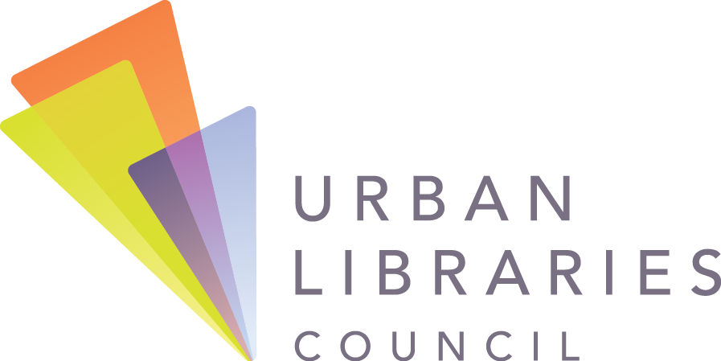
Statement on Equitable Public Access to E-Books
Major publishers have introduced severe restrictions to e-book and e-audiobook lending for public libraries, including embargoes on the sales of new titles and unreasonably high prices, which far exceed the prices offered for print books. As a result, libraries will be unable to fulfill their core functions in building educated, literate communities. These restrictions will be most harmful for populations who already face significant barriers to equitable knowledge and information access in our communities – including youth, people living with disabilities and those with limited financial means.
Public libraries play an essential role in leveling the playing field and strengthening the foundation of our communities. As digital technologies become increasingly inseparable from the ways that people learn, work and interact, the library’s unique ability to create onramps for information and knowledge access is more important than ever. There is significant, rising demand for e-books and e-audiobooks from public library users – overall, digital content circulation is increasing by 30% per year.
As elected public officials and trusted leaders in our communities, we are committed to protecting and supporting the capacity of public libraries to:
- Provide equal access for individuals to gain knowledge and become proficient with digital tools, regardless of their income, physical abilities, age, gender, sexual orientation, race, citizenship status or religion.
- Support lifelong learning and foster empathy, curiosity, civic engagement and a love of reading among community members.
- Educate community members about the rights, responsibilities and implications of their lives online, including data privacy risks when accessing online learning resources and digital content.
- Serve as valued partners to local government in advancing city/county outcomes for digital inclusion and as institutions that support informed citizens.
Our cities and counties are strongest when all individuals have the same opportunities to further their personal, educational and professional goals. Our democracy is non-negotiable. We stand with all who are urging e-book and e-audiobook publishers to institute fair, transparent and flexible lending models for public libraries.

