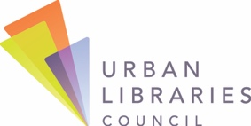
MakerSpace Description

LIBRARY: CONTACT NAME:

MAKERSPACE: CONTACT EMAIL:

COMMUNITY CONTACT PHONE:
PARTNERS:

PLEASE LIMIT EACH RESPONSE TO A MAXIMUM OF 250 WORDS.

MAKERSPACE DESCRIPTION (Please identify the target audience and age group, if applicable. Describe how your MakerSpace supports active learning, connection to STEM learning, entrepreneurship and innovation.)

OUTCOMES (Please describe positive outcomes accomplished. Achievements may range from acquiring new skills to creation of a new product.)

EMAIL APPLICATIONS TO: info@urbanlibraries.org.

1333 H Street, NW, Suite 1000 West, Washington, DC 20005 | 202-750-8650 | UrbanLibraries.org | INSPIRING LIBRARIES. TRANSFORMING COMMUNITIES.

